

Pennsylvania Dental Association
Insurance Services, Inc.

2014

ANNUAL REPORT

Presented to the

Pennsylvania Dental Association
House of Delegates
Notice of Annual Meeting of the Shareholder
of the Pennsylvania Dental Association Insurance Services, Inc.

To: Pennsylvania Dental Association

You are hereby notified of the call of the annual meeting of the shareholder of the above corporation to be held on Friday, April 25, 2014, at 2:00 p.m. at the Hershey Hotel, Hershey, Pennsylvania for the purpose of considering all business of the Corporation, including election of Directors, amendment of bylaws, matters of financing, and any other matter which may come before the shareholders.

For the Corporation



______________________________
Camille Kostelac-Cherry, Esq.
Secretary

Dated: March 05, 2014

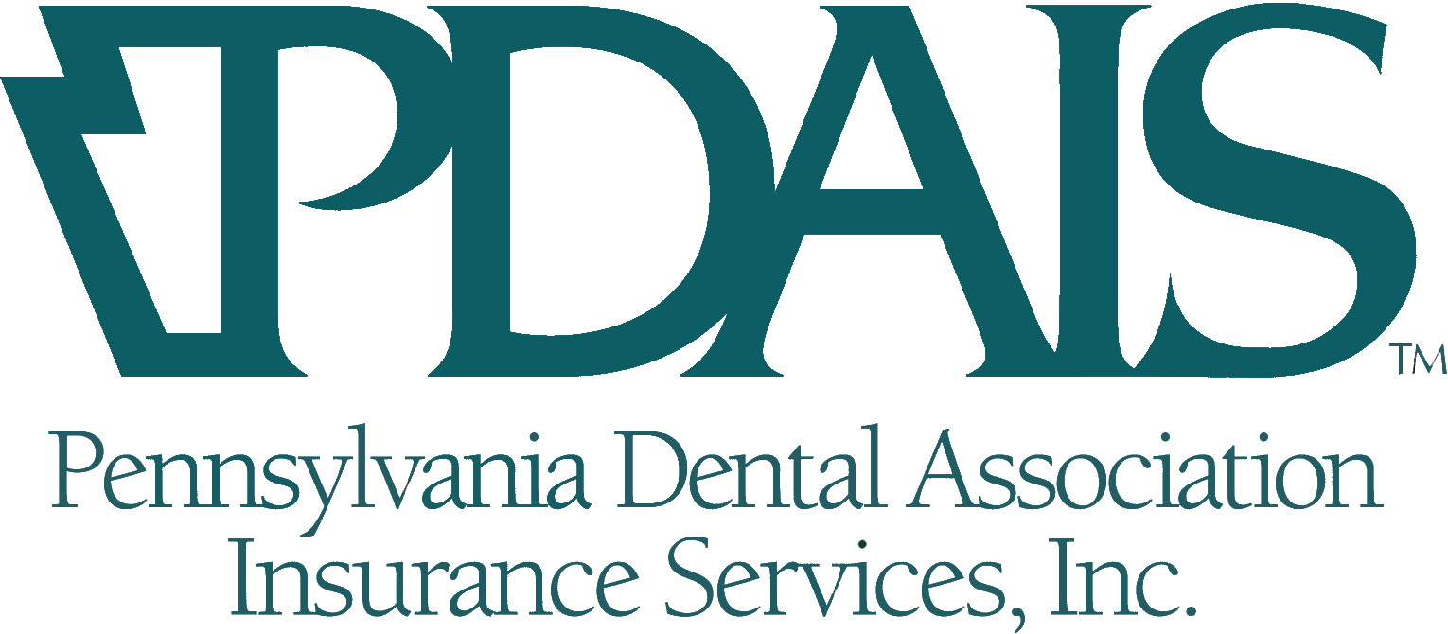

Annual Shareholders Meeting

AGENDA
April 25, 2014

- Approval of 2013 Shareholders Meeting Minutes

- Chairman’s Report – Dr. Jon Johnston

    - 2013 Review
    - Approve PDAIS Slate of Directors

- CEO Report – Gilbert Davis

    - 2013 Highlights
    - PDA Endorsed Vendors Update
    - 2013 Audit

- Old Business

- New Business – Dr. Jon Johnston
    - Presentation of PDA Dividend

- Motion to Adjourn

Pennsylvania Dental Association Insurance Services
Minutes of 2013 Shareholder Meeting

Dr. Jon Johnston called the 2013 Pennsylvania Dental Association Insurance Services (PDAIS) Shareholders Meeting to order at 3:00 p.m. on Friday, April 26, 2013. A motion was made to approve the minutes from the 2012 Shareholders Meeting. The motion was seconded and carried.
Dr. Johnston reported that PDAIS had a good year despite the multiple issues facing the insurance industry within the past few years. Dr. Johnston extended his gratitude to the members of the Board of Directors for their time and service.
Dr. Jack Aughenbaugh and Dr. Brian Christian have completed their terms of service on the Board of Directors and were nominated to serve another term. Being that there were no nominations from the floor, Dr. Aughenbaugh and Dr. Christian were elected to serve an additional term by unanimous ballot.
Gil Davis, PDAIS President and CEO, extended his thanks to all PDA members for their continued support of PDAIS. Mr. Davis also wished to thank the PDAIS Board of Directors for their time and commitment to PDAIS, as well as to PDAIS staff for all of their hard work.
PDAIS will be facing additional challenges throughout the coming year with implementation of the Affordable Healthcare Act. Mr. Davis stated that PDAIS is doing everything it can to be in the best position possible on January 1, 2014, when the act goes into effect, and that PDAIS will help members to navigate the changes that will take place as a result.
On behalf of The Dentist’s Insurance Company (TDIC), Mr. Davis thanked the members for their support and for the continued relationship TDIC has with PDAIS. As of January, PDAIS successfully negotiated a 25 percent credit with TDIC to be applied to professional liability policies. Since its inception 30 years ago, TDIC has given $480,000 back to PDA through dividends, and $68 million to organized dentistry nationwide.
Through dividends, royalties and continuing education sponsorships, PDAIS has given a total of $292,000 to PDA this year, for a 13 year total of 2.2 million dollars.
For 2011-2012, the Endorsed Vendor Program saw a 19 percent increase in royalties. ECCA Payroll and Business Solutions was recently added as a new endorsed vendor and offers payroll services to members.
Mr. Davis encouraged members to participate in a webinar being co-sponsored by PDA and PDAIS on May 14 that will discuss effects of the Affordable Care Act on the dental office.
PDAIS received a clean audit for 2012.
Dr. Johnston presented a dividend check in the amount of $50,000 to Dr. Bernie Dishler, PDA President. The meeting was adjourned at 3:20 p.m.
PDAIS
2013 Year End Update
January 1, 2013 – December 31, 2013
Submitted by
Gil Davis
Chief Executive Officer

PDAIS Mission
PDAIS exists to provide competitively priced, quality insurance products to PDAIS clients, their employees and families, as charged through the endorsement of the Pennsylvania Dental Association. The five key measures that help us understand whether or not PDAIS is following its mission and doing its job can be defined by our commitment, high ethical standards, growth, customer service and quality products. While practical measures are not necessarily indicators of health and depth of commitment, they do serve as barometers that help us ask the appropriate questions. This year-end report will attempt to highlight in abbreviated fashion the accomplishments of the past 12 months.
PDAIS 2013 Highlights:

Products/Growth

- Increased growth, for 2013, with TDIC by 11% in new client growth and 6.5% in written premium growth. TDIC also granted PDAIS for the tenth consecutive year a dividend of 8%. Mid-Atlantic Insurance Resources growth was up 15% in new client growth, but 15.7% in written premium growth and a fourth consecutive dividend of 8%. Total TDIC PDA member penetration is 13%.
- The workers compensation program with Eastern Alliance Insurance group grew by 24.5% in written premium with and a three year loss ratio of 13%.
- Our business property program, with Ohio Casualty grew by 12.9% with a three year loss ratio of 72.7%.
- The benefits department continues to struggle with new business, due to the challenges with the full implementation of the Affordable Care Act (ACA). We had a decrease in new business sales and a moderate decrease in total written premium. This is mainly due to the transferring of clients from the 21 County health insurance program, written through Capital BlueCross.
- The Liberty Mutual personal lines program was flat with a slight decrease in number of new clients (-1%), but increase in written premium of 3.3%.
- With all this growth and challenges, the agency is still able to maintain an overall retention of 94%.
- We also wrote a number of disability, life and long-term care insurance policies.

Commitment

- PDAIS completed its third year managing the PDA Endorsed programs, with 10% increase in royalty revenue. * See the attached endorsed vendor’s program report for additional information.
- PDAIS continued to provide non-dues revenue to the PDA and local dental societies with a 2013 total of $274,395 for a 14 year total of $2,480,170.
- PDAIS sponsored and attended 64 CE, study clubs, etc. throughout the commonwealth and three programs in NJ.
- The PDAIS sales staff continues to do specific target market campaigns to non-PDA member dentists.
- The PDAIS benefits department is providing assistance to PDA members doing this monumental change in the health insurance environment.
- Again this year PDAIS financial support was able to contribute to the success of the PDA New Member Dentist and Student Outreach programs, supplied significant financial support to PDA’s CE programs and continued its financial support of the PDA annual meeting.

Please reference the production reports and unaudited attached financial statements.
(2013 Audit will be available at the annual meeting.)

Financial Statements

As indicated on the enclosed financial statements, in 2013 we experienced an increase in overall gross revenue 6.4%, and overall, 2013 was our most successful year for PDAIS and MAIR. Our interest and investment income grew by .42% and an increase in our expenses by (4.5%), of which resulted in a net income, after operational expenses and before taxes, of $209,529.35. Our realized and unrealized investment income generated a total net income of $283,151.80. These favorable results are due to a strong focus and commitment to growth and disciplined spending. Also, remember that $274,000 of the PDA marketing fee and local royalty dollars would be considered as a return of profit in net income in a standard insurance agency mode, which would bring our total income to $474,113.

Threat

In the year of 2015, PDAIS will experience significant decrease in its gross revenue mainly due to the dissolution of its 21 County Association health insurance plan, due to the Affordable Care Act. With full implementation of the federal health insurance exchange in 2014, all of the association will be placed in the small business pull with a totally different compensation structure. Secondly, the Medical Loss Ratio legislation stipulates that 85% of group and 80% of individual premiums must go to paying claims. Current regulations require the companies to include payments to agencies and brokers as commissions in the 15-20% administrative fee costs. Therefore, commissions have already been decreased and by 2015 with full implementation of the bill they may be reduced more. However, due to the mandate that everyone will need to purchase health insurance, we are remaining optimistic that we will be able to write new business; but the question remains, will it be enough to offset some erosion.

Pennsylvania Dental Association Insurance Services, Inc.

Board of Directors

The current PDAIS Board of Directors:

Dr. Jon Johnston, Chairman
Dr. Eric Shirley, Vice-Chairman
Dr. Stephen Radack, III. Treasurer
Camille Kostelac-Cherry, Esq., Secretary
Dr. Samuel Selcher, (PDA Liaison)
Dr. Nancy Koshetar, Director
Dr. Jack A. Aughenbaugh, Jr, Director
Dr. Brian D. Christian, Director
Dr. Elaine Stefanowicz, Director

PDAIS Consultants

Legal Counsel
Goldberg & Katzman
Thomas J. Weber, Esq.

Accountant
Pennsylvania Dental Association
Leo Walchak, Controller

Auditors/Tax advisors
MaherDuessel
Lisa A. Ritter, CPA, CFP

Production Analysis
1/1/2013 - 12/31/2013
Company Volumn |  |  |  |  |  |  | Premium |  |  |  |  |  |  | Agency  Comm |  |  |  | Total Customers |  |  |  |  | Total Policies
Banyan Consulting LLC |  |  |  |  |  | 12,384,637.65 |  | 705,423.12 |  |  |  |  |  |  |  |  | 548 |  |  |  |  | 974
Independence Blue Cross |  |  |  |  |  | 2,403,178.42 |  | 119,659.62 |  |  |  |  |  |  |  |  | 154 |  |  |  | 285
TDIC - PDAIS |  |  |  |  |  | 1,308,837.00 |  | 196,325.55 |  |  |  |  |  |  |  |  | 669 |  |  |  |  | 865
Liberty Mutual |  |  |  |  |  | 889,054.00 |  | 121,934.66 |  |  |  |  |  |  |  |  | 320 |  |  |  |  | 709
American Insurance Admim |  |  |  |  |  | 878,575.06 |  | 31,749.54 |  |  |  |  |  |  |  |  | 66 |  |  |  |  | 110
Aetna Health |  |  |  |  |  | 766,379.60 |  | 66,497.90 |  |  |  |  |  |  |  |  | 95 |  |  |  |  | 159
Liberty PERSONAL LINES |  |  |  |  |  | 626,578.00 |  | 6,730.96 |  |  |  |  |  |  |  |  | 196 |  |  |  |  | 515
Eastern Alliance Insurance Group |  |  |  |  |  | 577,397.67 |  | 56,070.29 |  |  |  |  |  |  |  |  | 374 |  |  |  |  | 717
TDIC-MAIR |  |  |  |  |  | 483,152.40 |  | 72,472.86 |  |  |  |  |  |  |  |  | 207 |  |  |  |  | 284
The Hartford/BOE, DI |  |  |  |  |  | 261,390.76 |  | 52,278.42 |  |  |  |  |  |  |  |  | 209 |  |  |  |  | 452
ARMS Insurance Company Inc |  |  |  |  |  | 238,703.42 |  | 29,467.45 |  |  |  |  |  |  |  |  | 77 |  |  |  |  | 110
Guardian |  |  |  |  |  | 92,856.02 |  | 9,500.86 |  |  |  |  |  |  |  |  | 19 |  |  |  |  | 51
Partners Specialty |  |  |  |  |  | 91,765.00 |  | 9,035.56 |  |  |  |  |  |  |  |  | 9 |  |  |  |  | 9
Woodmen of the World |  |  |  |  |  | 90,607.93 |  | 15,454.71 |  |  |  |  |  |  |  |  | 54 |  |  |  |  | 105
Millers Mutual Group |  |  |  |  |  | 75,877.75 |  | 14,791.63 |  |  |  |  |  |  |  |  | 40 |  |  |  |  | 54
Fortis |  |  |  |  |  | 62,359.88 |  | 3,021.49 |  |  |  |  |  |  |  |  | 20 |  |  |  |  | 38
Philadelphia |  |  |  |  |  | 52,005.44 |  | 7,999.53 |  |  |  |  |  |  |  |  | 18 |  |  |  |  | 22
National Fire & Marine Co. |  |  |  |  |  | 49,080.00 |  | 3,806.00 |  |  |  |  |  |  |  |  | 2 |  |  |  |  | 2
Standard Insurance |  |  |  |  |  | 39,118.07 |  | 7,408.86 |  |  |  |  |  |  |  |  | 15 |  |  |  |  | 44
Murray Insurance Associates |  |  |  |  |  | 38,468.00 |  | 2,502.20 |  |  |  |  |  |  |  |  | 1 |  |  |  |  | 3
Colonial Supplemental Insurance |  |  |  |  |  | 36,909.05 |  | 1,751.86 |  |  |  |  |  |  |  |  | 12 |  |  |  |  | 24
Meadowbrook Insurance Group |  |  |  |  |  | 33,572.90 |  | 3,357.30 |  |  |  |  |  |  |  |  | 21 |  |  |  |  | 24
Chubb |  |  |  |  |  | 27,842.20 |  | 2,567.74 |  |  |  |  |  |  |  |  | 8 |  |  |  |  | 16
Companion Commercial Co. |  |  |  |  |  | 26,377.50 |  | 1,770.93 |  |  |  |  |  |  |  |  | 1 |  |  |  |  | 2
URL |  |  |  |  |  | 21,795.76 |  | 21,795.76 |  |  |  |  |  |  |  |  | 175 |  |  |  |  | 276
MedAmerica Insurance Company |  |  |  |  |  | 16,536.32 |  | 1,348.16 |  |  |  |  |  |  |  |  | 18 |  |  |  |  | 18
Catlin Specialty Co. |  |  |  |  |  | 15,500.00 |  | 1,550.00 |  |  |  |  |  |  |  |  | 2 |  |  |  |  | 2
Columbia Casualty Company |  |  |  |  |  | 13,182.00 |  | 988.65 |  |  |  |  |  |  |  |  | 1 |  |  |  |  | 1
Insurance Agents & Brokers |  |  |  |  |  | 13,124.00 |  | 1,049.92 |  |  |  |  |  |  |  |  | 7 |  |  |  |  | 13
CNA Continental Casualty Comp |  |  |  |  |  | 13,046.87 |  | 391.39 |  |  |  |  |  |  |  |  | 9 |  |  |  |  | 9
Company Volumn |  |  |  |  |  |  | Premium |  |  |  |  |  |  | Agency  Comm |  |  |  | Total Customers |  |  |  |  | Total Policies
Dearborn National Life Insurance Company |  |  |  |  |  | 11,766.00 |  | 2,941.50 |  |  |  |  |  |  |  |  | 7 |  |  |  |  | 14
Admiral Insurance |  |  |  |  |  | 11,401.00 |  | 1,140.10 |  |  |  |  |  |  |  |  | 2 |  |  |  |  | 2
Union Central |  |  |  |  |  | 11,325.76 |  | 673.60 |  |  |  |  |  |  |  |  | 3 |  |  |  |  | 5
United Concordia |  |  |  |  |  | 10,742.43 |  | 1,229.96 |  |  |  |  |  |  |  |  | 7 |  |  |  |  | 9
Selective Insurance Company of America |  |  |  |  |  | 10,137.00 |  | 1,520.55 |  |  |  |  |  |  |  |  | 3 |  |  |  |  | 5
Humana |  |  |  |  |  | 7,964.32 |  | 318.60 |  |  |  |  |  |  |  |  | 1 |  |  |  |  | 4
Gerber Life Insurance Company |  |  |  |  |  | 6,961.46 |  | 986.38 |  |  |  |  |  |  |  |  | 5 |  |  |  |  | 9
Travelers Casualty & Surety |  |  |  |  |  | 5,732.00 |  | 573.20 |  |  |  |  |  |  |  |  | 3 |  |  |  |  | 5
ACE American Insurance Company |  |  |  |  |  | 5,390.00 |  | 404.25 |  |  |  |  |  |  |  |  | 2 |  |  |  |  | 2
American General Life Insurance Company |  |  |  |  |  | 4,847.60 |  | 3,878.08 |  |  |  |  |  |  |  |  | 3 |  |  |  |  | 3
Harleysville |  |  |  |  |  | 4,390.00 |  |  | 439.00 |  |  |  |  |  |  | 1 |  |  |  | 4
Principal Financial Group |  |  |  |  |  | 4,367.00 |  |  | 531.09 |  |  |  |  |  |  | 1 |  |  |  | 3
Genworth |  |  |  |  |  | 4,172.58 |  |  | 1,403.30 |  |  |  |  |  |  | 6 |  |  |  | 6
Cigna |  |  |  |  |  | 3,375.12 |  |  | 3,375.12 |  |  |  |  |  |  | 104 |  |  |  | 176
Evanston |  |  |  |  |  | 2,660.00 |  |  | 266.00 |  |  |  |  |  |  | 1 |  |  |  | 1
Savings Bank Life Insurance Company of Massachusetts |  |  |  |  |  | 2,332.62 |  |  | 1,941.11 |  |  |  |  |  |  | 6 |  |  |  | 6
American Medical Security |  |  |  |  |  | 1,938.92 |  |  | 99.43 |  |  |  |  |  |  | 1 |  |  |  | 2
International Medical Group |  |  |  |  |  | 1,699.40 |  |  | 220.92 |  |  |  |  |  |  | 8 |  |  |  | 12
Wells Fargo Special Risks, Inc. |  |  |  |  |  | 1,323.00 |  |  | 132.30 |  |  |  |  |  |  | 1 |  |  |  | 1
Brokers National |  |  |  |  |  | 1,123.40 |  |  | 134.85 |  |  |  |  |  |  | 2 |  |  |  | 4
Banner Life |  |  |  |  |  | 696.00 |  |  | 487.20 |  |  |  |  |  |  | 1 |  |  |  | 1
Zenith Marketing Group |  |  |  |  |  | 440.36 |  |  | 264.40 |  |  |  |  |  |  | 2 |  |  |  | 2
Maxum Indemnity Company |  |  |  |  |  | 395.00 |  |  | 19.75 |  |  |  |  |  |  | 1 |  |  |  | 2
Ranking Totals
 |  |  |  |  |  | 21,743,090.64 |  |  |  |  |  |  | 1,591,684.00 |  |  | 3,519 |  |  |  | 6,171

Pennsylvania Dental Association Insurance Services, Inc.

Board of Directors Nominations

2014 - 2015

Below are list of the current PDAIS Board of Directors:

District *Term Expiration
Dr. Jack A. Aughenbaugh, Jr. 4 2017
Dr. Brian D. Christian 7 2017
Camille Kostelac-Cherry Unlimited
Dr. Samuel Selcher (PDA Liaison) 5 Unlimited
Dr. Jon Johnston 8 2016
Dr. Stephen T. Radack 9 2014
Dr. Nancy Koshetar 2 2019
Dr. Eric L. Shirley 5 2018
Dr. Elaine Stefanowicz 1 2016

The Directors shall be elected by the shareholder at the annual meeting of the shareholder of the corporation, and each Director shall be elected for a term of two years, but shall not be allowed to serve more than six consecutive years.

Slate of directors up for reelection is:

- Dr. Jon Johnston
- Dr. Eric Shirley
- Dr. Elaine Stefanowicz

*Term Expiration represents the final year of the Directors’ 6-year term if re-elected by the House of Delegates every 2 years.

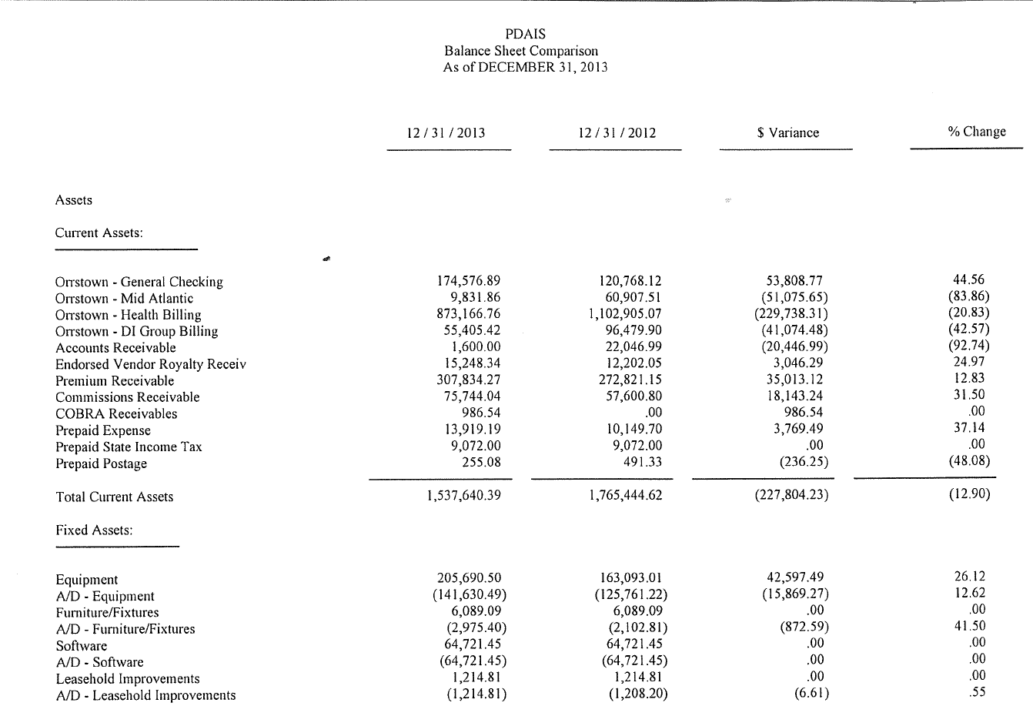
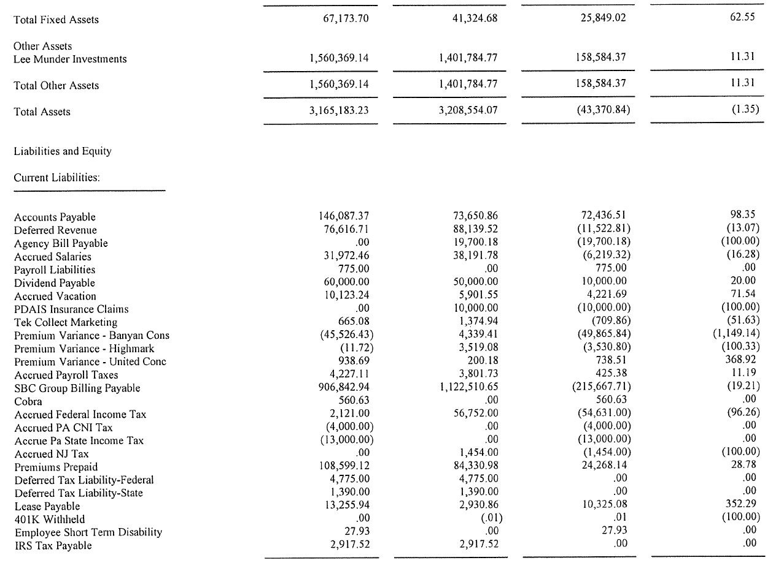
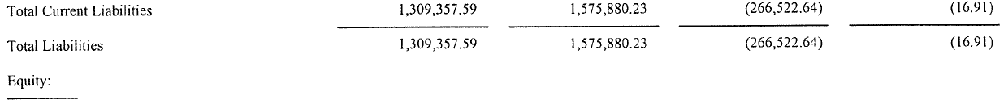
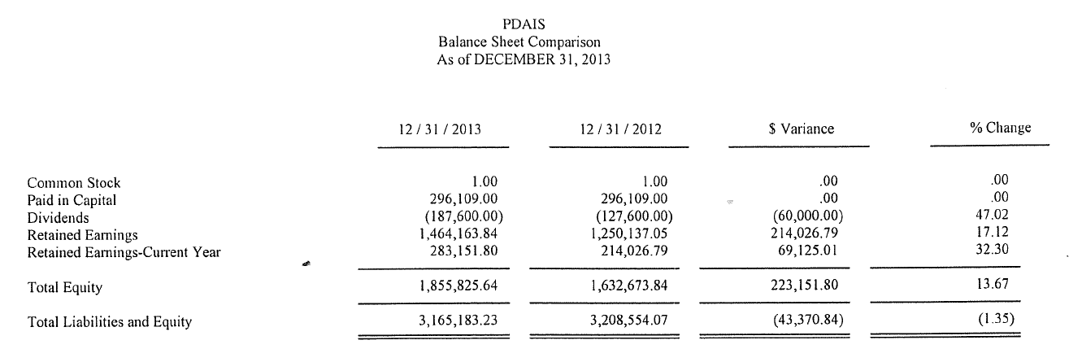

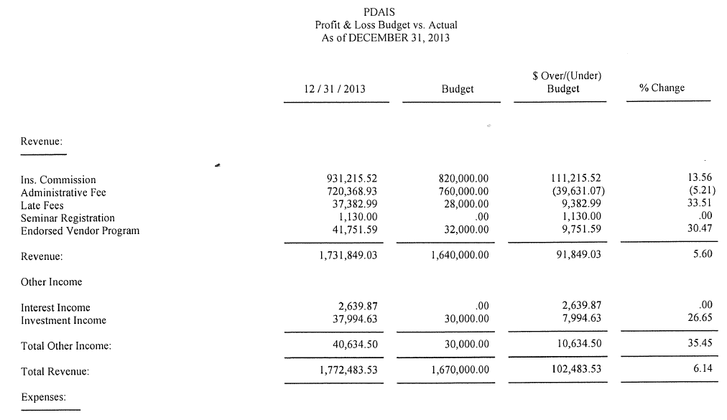
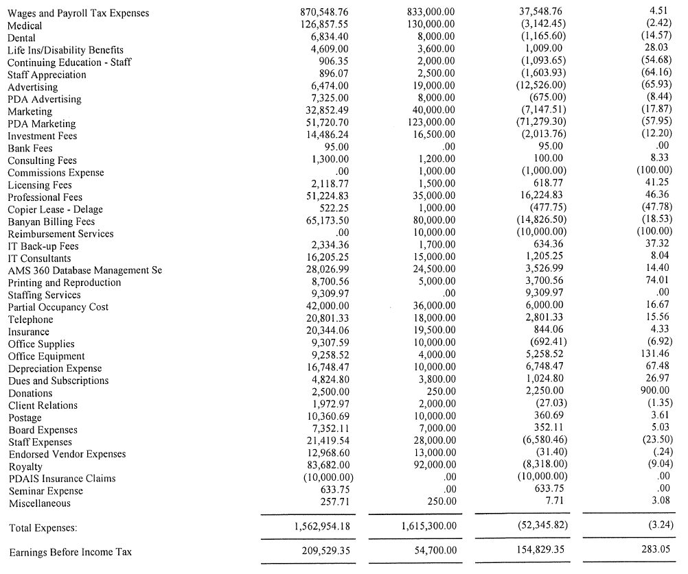
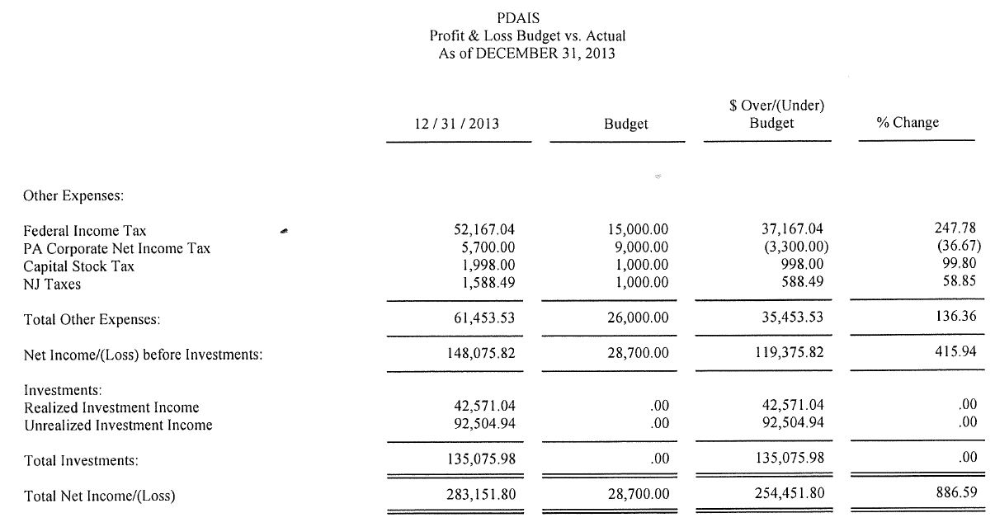

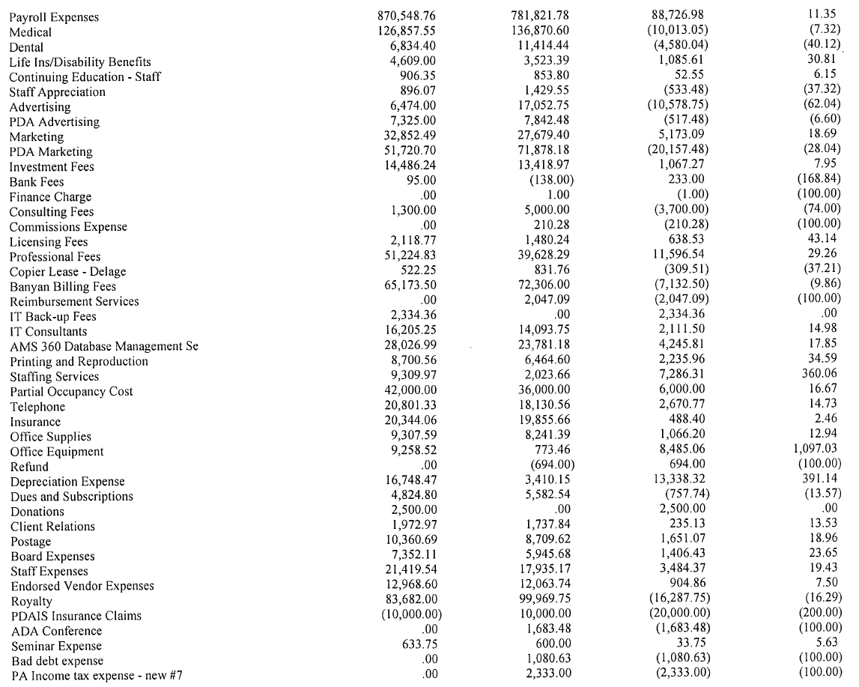
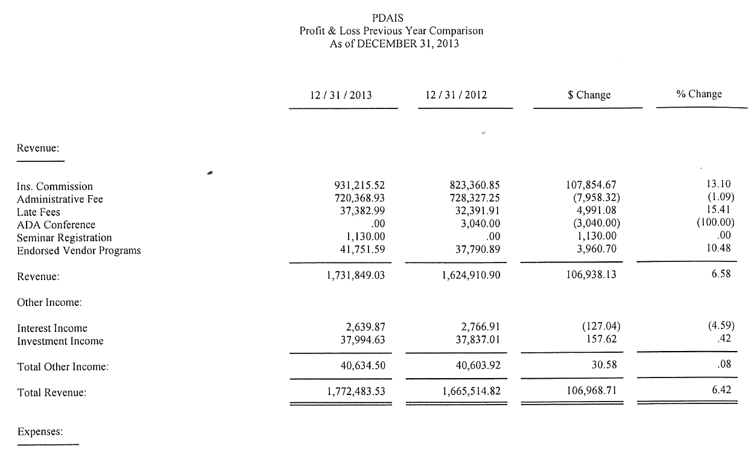
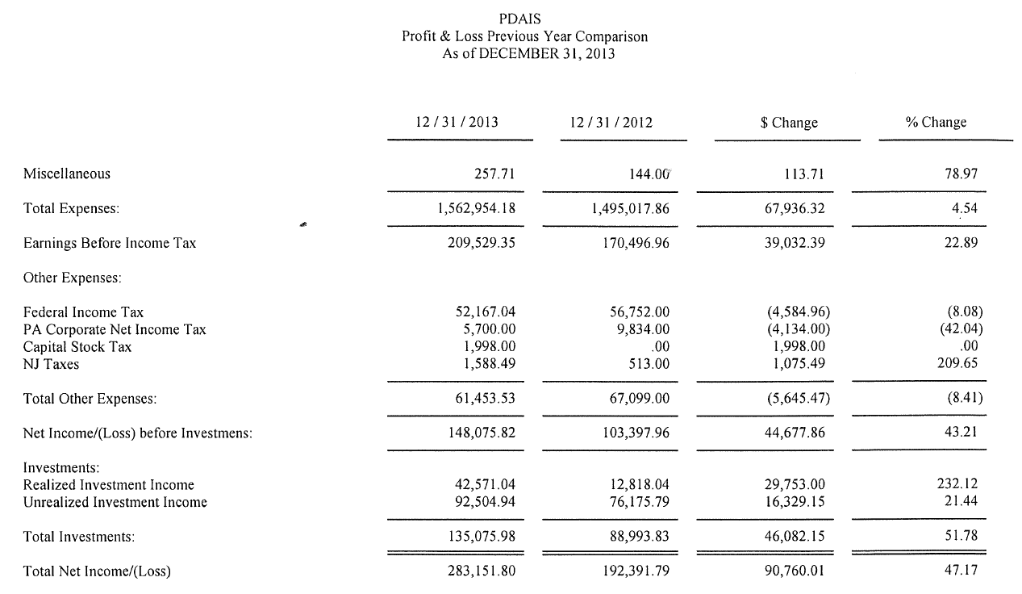
DIVIDENDS AND CONTRIBUTIONS TO THE PDA

The graph below illustrates the dividends and contributions to the PDA. Also, the additional contributions by PDAIS allow important issues/events to be held without the potential dues assessment or the possibility of not having the events.

We are facing some financial challenges in 2015 that could significantly affect our royalty payments. However, if we can obtain more participation of the PDA leadership and members in PDAIS’ programs, we can minimize the financial impact. The additional business will allow us to continue to maintain the payments at the same level or strengthen our ability to increase contributions to the PDA.

Total PDA Contributions
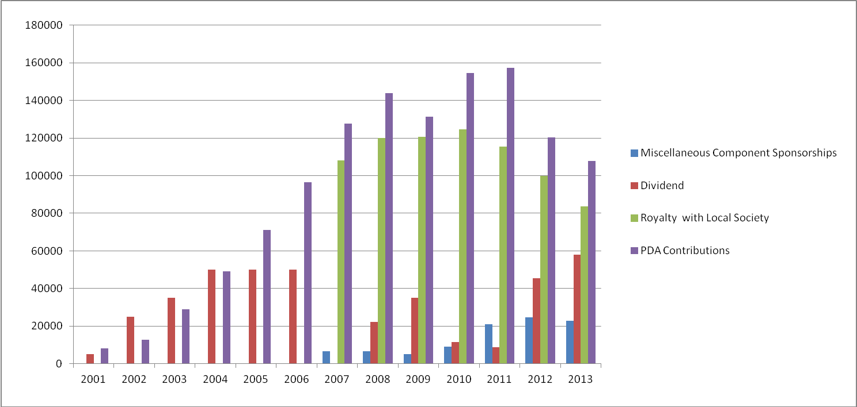

TOTAL FOR THE 14 YEARS $2,480,170

Pennsylvania Dental Association Insurance Services

Board of Directors

PDAIS would like to express its sincere appreciation and thanks to the Board of Directors for their years of distinguished service.

CURRENT BOARD MEMBERS FORMER BOARD MEMBERS 1999 – 2014

Dr. Jon J. Johnston, Chairman Dr. Jerrold H. Axler Dr. Eric L. Shirley, Vice-Chairman Dr. Henry J. Bitar
Dr. Stephen T. Radack, III, Treasurer Dr. Richard R. Grossman
Ms. Camille Kostelac-Cherry, Esq. Secretary Dr. R. Donald Hoffman
Dr. Jack A. Aughenbaugh, Jr., Director Dr. Eugene Katz, President Emeritus
Dr. Brian D. Christian, Director Dr. Lawrence M. Kenney
Dr. Samuel E. Selcher, Director Dr. Robert Kramer
Dr. Elaine D. Stefanowicz, Director Dr. Marlin A. Miller*
Dr. Nancy Koshetar, Director Dr. David P. Paolini
Dr. Michael A. Reed
Dr. Louis F. Rubino, Jr.
Dr. Donald C. Sarandria Dr. Robert D. Stainbrook
Dr. J. Brian Straka
Dr. Stanley P. Toplan
Dr. John J. Tully

*Deceased

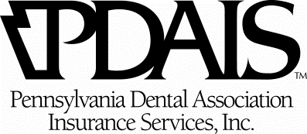

PDA Endorsed Programs
As of February 28, 2014
PDA Endorsed Vendor – EOY 2012/2013 Comparisons
Vendor | Total  2012 EOY |  | Total  2013 EOY | Difference +/-
Bank of America - Cards | $66,376 |  | $64,554 | ($1,822)
Bank of America – | 49,352 |  | 72,940 | 23,588
Practice Solutions |  |  | 72,940 | 23,588
Care Credit | 44,444 |  | 49,596 | 5,152
CES | 20 |  | 881 | 861
D-MMEX | 3,405 |  | 2,396 | (1,009)
Demandforce | 1,400 |  | 2,200 | 800
Elavon (Termed Agreement) | 7,837 |  | 1,147 | (6,690)
Energy Plus | 755 |  | 2,019 | 1,264
First Data | 0 |  | 1,273 | 1,273
ProSites | 5,537 |  | 4,888 | (649)
TekCollect | 10,000 |  | 7,500 | (2,500)
Total Year-to-date | $189,126 |  | $209,394 | $20,268

Support Commitment from Endorsed Vendors as of March 7, 2014
Vendor | 2011  PDA Journal/  eNews | 2012  PDA Journal/  eNews | 2013  PDA Journal/  eNews | 2014  PDA Journal/  eNews | Total
CareCredit | $ 650 | $ 0 | $ 0 | $ 1,400 | $ 2,050
Demandforce | 0 | 8,730 | 5,820 | 850 | 15,400
Bank of America | 0 | 0 | 0 | 1,400 | 1,400
Elavon | 495 | 0 | 0 | 0 | 495
D-MMEX | 565 | 2,630 | 3,945 | 0 | 7,140
ProSites | 4,550 | 7,050 | 7,050 | 7,050 | 25,700
TekCollect  eNews | 1,400 | 1,400 | 1,400  575 | 0 | 4,200  575
PDAIS – Vendor Spotlight | 0 | 1,450 | 1,450 | 1,560 | 4,460
Subtotal | $ 7,660 | $ 21,260 | $ 20,240 | $ 12,260 | $ 61,420
PDA CE/Annual Session
First Data | 500 | 0 | 500  Reading | 0 | 1,000
DemandForce  Presidents Circle | 0 | 0 | 0 | 4,000 | 4,000
ProSites – Annual Session  Trustee Circle | 0 | 2,000 | 0 | 0 | 2,000
ProSites – Annual Session  Member’s Circle | 0 | 0 | 500 | 0 | 500
TekCollect – PDA CE | 0 | 0 | 500  Bedford | 0 | 500
TekCollect – Annual Session  Trustee Circle | 0 | 0 | 2,000 | 0 | 2,000
TOTAL | $ 8,160 | $ 23,260 | $ 23,740 | $ 16,260 | $ 71,420
PDAIS INSURANCE PROGRAMS AND COMPANIES

Professional Liability and General Liability Insurance through
- The Dentists Insurance Company (TDIC)

Business Property Insurance available through
- The Dentists Insurance Company (TDIC)
- Ohio Casualty Insurance Company
- Millers Mutual

Business Overhead Expense Insurance
- Group offered through Hartford Life Insurance Company
- Individual offered through Union Central Life with a 15% PDA member discount

Workers Compensation
- Eastern Alliance Insurance Group
- Ohio Casualty Insurance Company

Employment Practice Liability Insurance (EPLI)
- TDIC
- Philadelphia Insurance Company

Flood Insurance
- Selective Insurance Company

Health Insurance (Group & Individual)
- Capital BlueCross, Independence Blue Cross, Health America, Aetna, Highmark, Geisinger and UPMC

Health Savings Accounts
- Fortis, Health America, Highmark, Capital BlueCross and Aetna

Long Term Care Insurance
- Med America 10% discount
- John Hancock at 5% discount
- Mass Mutual at 10% discount

Long Term Disability Insurance
- Group offered through Hartford Life Insurance Company
- Individual through Guardian, Principal & Standard with a 10% PDA member discount

Group and Individual Term and Permanent Life Insurance
- Group offered through Fort Dearborn Life
- Individual through Prudential, First Colony, Empire General and others

Personal Auto, Homeowners and Personal Umbrella Liability
- Liberty Mutual Auto 20% discount and homeowners 10% discount for all PDA members

PDAIS INSURANCE PROGRAMS AND COMPANIES

Estate, Financial Planning
- uFinancial (formerly Wienken & Associates)
- PDA Member 401k plan through Great West Retirement Services

Medicare Supplement including Medicare D products
- Capital BlueCross, Highmark, Aetna, Cigna, Independence Blue Cross and Woodmen’s Insurance Group

Supplement Insurance (Voluntary Benefit Insurance products for the Dental Staff)
- Colonial Life and Accident Insurance Company
- Short Term Disability
- Long Term Disability
- Accident
- Cancer and Critical Illness
Pet Insurance (15% discount for PDA members)
- Offered through Petplan Insurance Company
